MEC Microclouds in 5G
Name: Abdullah, Al Sadah
Course: Cloud Computing System
Date: 5/6/2021

Abstract
Technological changes today reflect the increasing demands for better and quality services. The introduction of the 5G network is set to change the trends in the market. The high costs and complexity of the current models are expected to be resolved with the new generation network. MEC, which is one of the service providers set to benefit from the new generation network involves architectural shift and with the new network, it will reimagine its service edge that will address its user network volume and decomposition. This paper, using secondary resources, seeks to address the potential impacts of the 5G network and how it seeks to resolve the challenges service-providers as experiencing with respect to multi-access edge computing. The paper focuses on how the new network will support both infrastructure and cloud service use.
Key Words: 5G, MEC, Internet, Information Technology

Contents
Abstract 2
Introduction 4
MEC-Based Platform 4
5G Network 6
5G MEC-Based Innovation 7
Reduced Latency 7
Cost-Effectiveness 8
Conclusion 8
References 9

MEC Microclouds in 5G

Introduction
Technological advancement is changing the way people share information and ideas over the internet. With the emergence of the new network, 5G which is the new generation of global telecommunication networks, the network architecture is significantly changing access and sharing of information and data online. This paper examines the changes that 5G is bringing to the existing network infrastructure and how it aims to help resolve the traffic volume of data distributed through multi-access edge computing (MEC). This topic is important not only because it involves a current technological advancement, but also because it presents the best opportunity to understand the impact of a technological revolution in the current society.

MEC-Based Platform
MEC or multi-access edge computing is a cloud platform that provides new networks with the architecture to enable them to operate (China Mobile & ZTE, 2020). They also serve as a data plane for the service seekers. This platform using a mobile network to provide its information technology services as well as cloud computing functions. Therefore, it creates a carrier-class service environment with not only effective and efficient but also a high-performance service for its users (China Mobile & ZTE, 2020). MEC also provides low latency and high bandwidth, which makes it the best cloud computing service provider that attracts the greatest extent of customers. With all these features, MEC is considered to be an effective service that consumers enjoy due to its high-quality service experience (China Mobile & ZTE, 2020).
However, with the increasing growth of digital and intelligent computing, greater demand also expands for more sophisticated systems that can handle and accommodate the changes emerging. Demand is increasing on requirements for changing computing services, including terminal computing. Terminal computing is associated with certain limitations that the existing network systems have not been able to resolve, including moving the information to the cloud, costs, power consumption, and space capacities. While cloud computing capabilities are yet to prove efficiently capable to deal with the real-time service demand, the new technologies are presenting optimism that some of these challenges will be dealt with once the right infrastructure is established (Pham et al., 2020). According to Pham et al. (2020), during the last four decades, the evolution of technology, especially in the ICT has changed many things, including the very nature of human life. Since the emergence of the first generation cellular network in the 1980s, more than three decades ago, significant improvements have been witnessed in the current digital space. Pham et al. (2020) explain that several digital networks have been developed that have changed the current coverage, mobility, security, and privacy. Scholars appreciate the important role of information technologists who are changing the way the ICT market operates. With the 5th generation network now in the process of becoming a reality, much of the achievements in this sector are yet to be realized.
MEC services include cloud games, which are based on cloud computing. In cloud computing mode, all the games are operated on the cloud server while the rendered game images reach the users through a network. Unlike traditional gaming platforms, cloud computing has greatly changed the gaming industry. The current cloud computing games are more cost-effective compared to the traditional ones (China Mobile & ZTE, 2020). While many things have changed over the last four decades, the interaction latency, which many of these services depend on has not changed that much. That is why the emergence of the more powerful and faster network would be considered a revolutionary change in the cloud computing business.
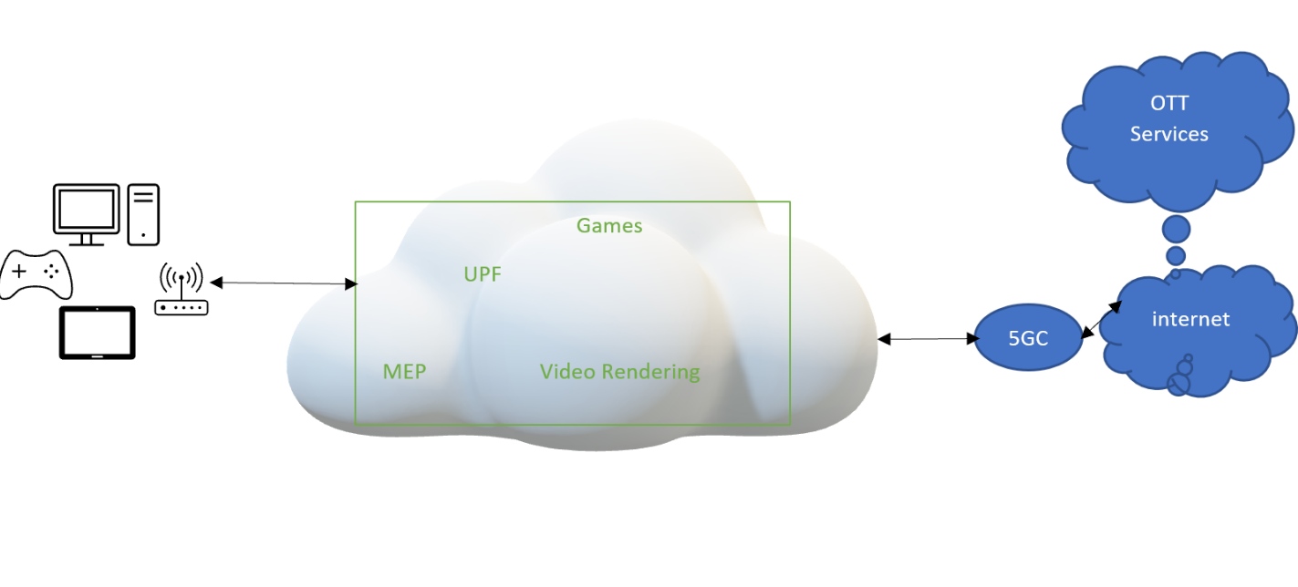
Figure (1) 5G MEC-Based Cloud Game Architecture
Local rendering
MEC
Edge Cloud Game Connector

5G Network
5G network is the new generation of telecommunication network, which is based on cloud-native and other sophisticated computing technologies. While the rollout of this technology has been marred with global politics, it is a reality that would soon change the history of the global telecommunication industry. Spinnelli and Mancuso (2020), 5G aims at becoming the new reference architecture for mobile and telecommunication networks. While it is not considered to be the only evolution of the currently and widely used 4G network, especially in terms of performance, it is believed that it has created a breaking point when compared to the previous generation networks.
5G network is set to bring new changes and resolve some of the problems that have continued to face the digital market, including slow performance and high cost of networking associated with the previous network generations. These advantages and benefits are enhanced in three categories:
First, it seeks to enhance mobile broadband, which will revolutionize the very nature of cellular network infrastructure. According to Spinelli and Mancuso (2020), the 5G network is characterized by very high rates and a high density of users. For example, some of the services that largely depended on mobile broadband such as virtual reality and even augmented reality, which require high-quality mobile video distribution are set to benefit greatly from this new technology because it performs beyond the expected capacity, which will increase video consumption.
Secondly, the new network is set to change and improve ultra-reliable as well low latency communications. This is where cloud computing businesses are set to benefit from because the new network will support their growth in many aspects. Ryu et al. (2019), 5G is set to benefit service-related businesses that require high demanding latency and reliable networks. Lastly, the new generation network is also set to change how the Internet of Things (IoT) communicates. While this may not be relevant to the current discussion, it is important to mention it because it is still related to the topic. 5G network is set to comprise a larger ecosystem than the previous generation networks. This network will not only provide service to the individual users, but it also targets businesses and companies.

5G MEC-Based Innovation
China, in 2019 showed its commitment to see the rollout of the 5G in the market. Despite the setbacks experienced over the last years, China Mobile’s partnership with ZTE to test cloud games in a 5G environment has proven to many cloud computing users that the network could be potential for cloud computing services such as MEC. This innovative cloud computing practice that was piloted in Guangzhou, China, has demonstrated that the 5G network could be a potential solution to some of the challenges that cloud computing businesses have been experiencing with the previous network generations. These potential benefits include:

Reduced Latency
Cloud computing, especially cloud games depend on the latency of the network. Low networks mean that their businesses will not perform as expected due to low transmission of data. However, with the introduction of 5G networks, this problem is set to change. The new network offers a highly effective and reliable network characterized by short transmission distance. With the low latency slices, the 5G network guarantees users as low latency as possible, which means increased productivity and performance (Pham et al., 2020).

Cost-Effectiveness
Every business wants to make a profit as much as they would get, but this also depends on the availability of efficient delivery methods which ensure that the product or service reaches the consumers in time. The cost of processing and distributing services can hinder the profitability of the firm. Therefore, any technology that seeks to reduce this cost will significantly impact service-providing businesses positively.

Conclusion
Technological evolution is changing the way businesses are performing and interacting with their customers. For service providers like cloud computing businesses, effectiveness relies on the ability to share data with the customer in time. The emergence of the 5G network is set to change the business environment for cloud computing by reducing the latency communication and the cost of doing business. All this means that they will make more profit than before. As discussed in this paper, 5G is different from the previous network generations. Piloting by China Mobile and ZTE of the 5G network on the cloud shows its compatibility with multi-access edge computing, which combines the traditional cellular networks with the internet services to minimize the latency of users. 5G network will have a greater impact on MEC by providing high bandwidth and low latency, which will reduce the cost-effectiveness of accessing cloud games.

References
China Mobile & ZTE. (2020). “Powered by SA: 5G MEC-Based Cloud Game Innovation Practice.” GSMA (online). https://www.gsma.com/futurenetworks/wp-content/uploads/2020/03/Powered-by-SA-5G-MEC-Based-Cloud-Game-Innovation-Practice-.pdf
Pham, Q. V., Fang, F., Ha, V. N., Piran, M. J., Le, M., Le, L. B., ... & Ding, Z. (2020). A survey of multi-access edge computing in 5G and beyond: Fundamentals, technology integration, and state-of-the-art. IEEE Access, 8, 116974-117017.
Ryu, J. W., Pham, Q. V., Luan, H. N., Hwang, W. J., Kim, J. D., & Lee, J. T. (2019). Multi-access edge computing empowered heterogeneous networks: A novel architecture and potential works. Symmetry, 11(7), 842.
Spinelli, F., & Mancuso, V. (2020). Towards enabled industrial verticals in 5G: a survey on MEC-based approaches to provisioning and flexibility. IEEE Communications Surveys & Tutorials.

